**Experiment: Common Source Amplifier using diode connected load**

**Aim:**

To implement a common source amplifier using diode connected load of gain 5 and analyze its transient and ac characteristics.

**Tool Used:**

LTspice

**Theory:**

The common-source (CS) amplifier for MOSFET is the analogue of the common emitter amplifier for BJT. Its popularity arises from its high gain, and that by cascading a number of them, larger amplification of the signal can be achieved.

For a Level 3 NMOS let’s assume

VGS = 0.6V

VT = 0.4V

VDD = 1.8V

Kn = 120µA/V2 ,

Which gives a value of (W/L) = 25 for 50uA ID.

The value of VDS should be maintained above (VGS - VT = 0.6 - 0.4 = 0.2V) for the transistor to stay in saturation region.

As W/L is 25, the width is taken as 250µm and the length is taken as 10µm.

The W/L of diode mosfet is taken 25 times lesser.

**Circuit Schematic:**

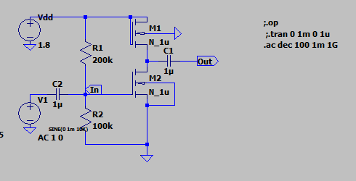

**Output Waveforms:**

**--- Operating Point ---**

**V(n001): 1.8 voltage**

**V(n002): 0.262348 voltage**

**V(in): 0.6 voltage**

**V(n003): 0 voltage**

**V(out): 2.62348e-007 voltage**

**Id(M2): 5.3556e-005 device_current**

**Ig(M2): 0 device_current**

**Ib(M2): -2.72348e-013 device_current**

**Is(M2): -5.3556e-005 device_current**

**Id(M1): 5.3556e-005 device_current**

**Ig(M1): 0 device_current**

**Ib(M1): -2.08235e-012 device_current**

**Is(M1): -5.3556e-005 device_current**

**I(C2): 6e-019 device_current**

**I(C1): -2.62348e-019 device_current**

**I(R2): 6e-006 device_current**

**I(R1): 6e-006 device_current**

**I(V1): 6e-019 device_current**

**I(Vdd): -5.9556e-005 device_current**

Transient characteristics

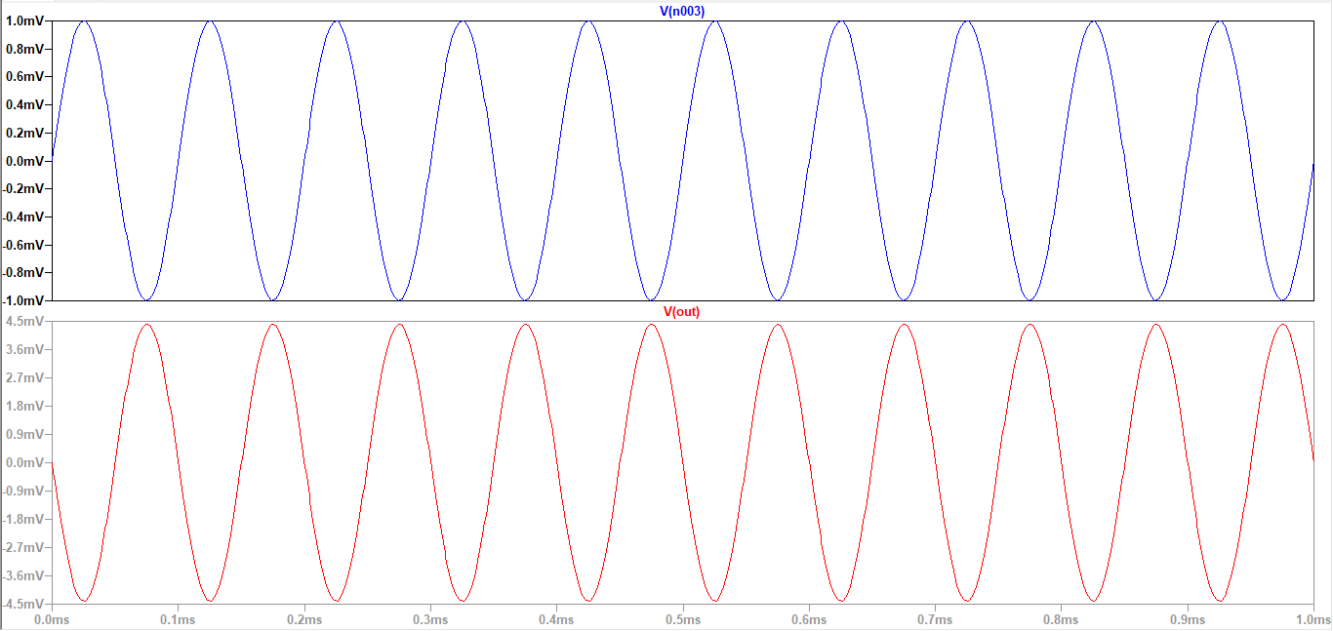

AC Analysis

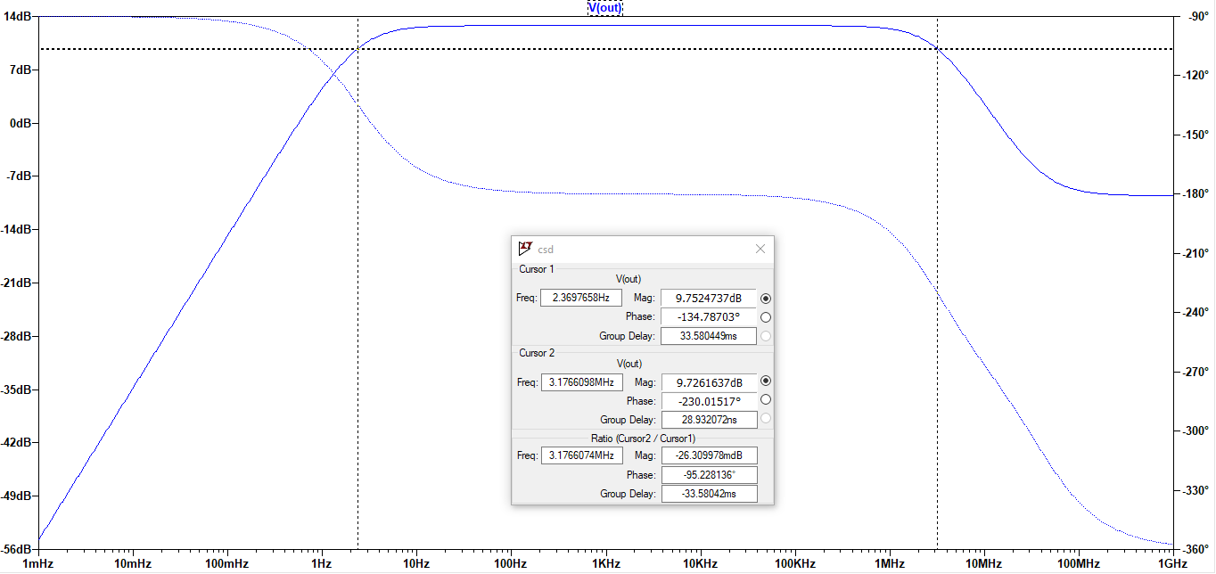

**Result:**

The circuit is designed for a gain of 5 and the output is verified to be correct.

* Bandwidth is obtained to be : 3.17MHz
* Cutoff Freq : 3.17MHz, 2.36Hz